CO2 ASSESSMENT TOOL-3

Q20. 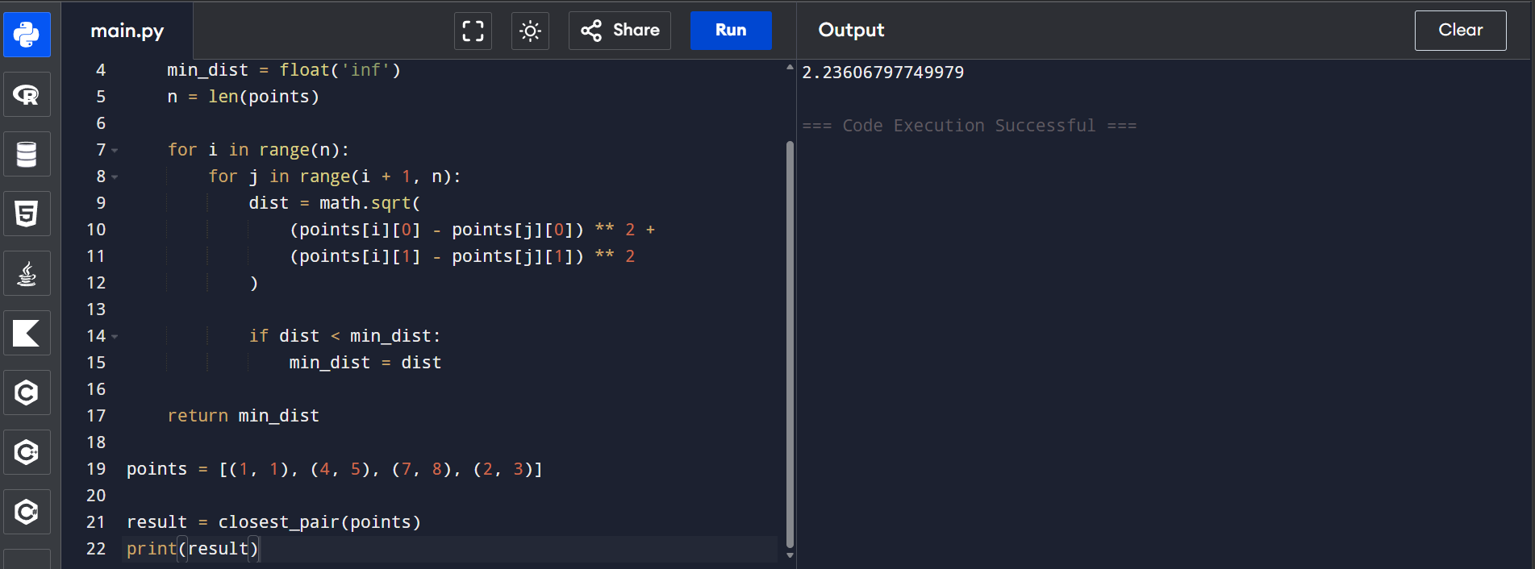

Q45.


